Our environment

Recycling

We should recycle to protect our environment. We should put plastic in a yellow trash can, paper in blue, glass in green and metal in red in red.

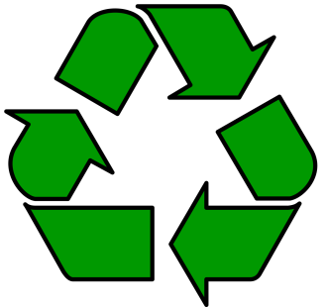 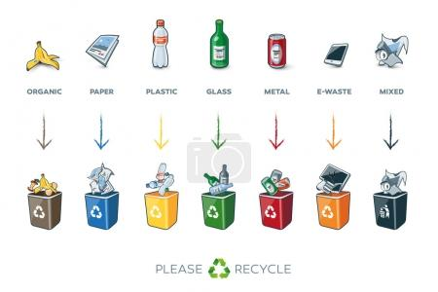

Water

We shouldn’t waste a lot of water. We should take a shower instead of bath.

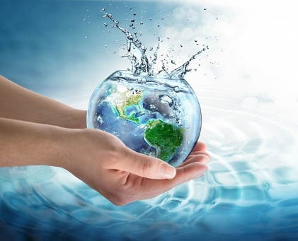 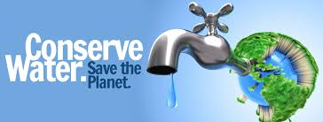

Air

We can help our environment with not driving cars or buses because it destroys our environment. We should walk, cycle or ride electronic buses or electronic cars.

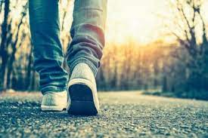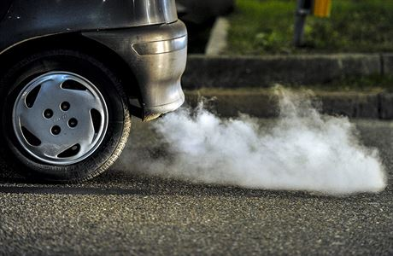

Trash

Wtoe should throw rubbish in the bin and not in the woods and anywhere else to protect nature. We should use paper cups and not plastic ones.

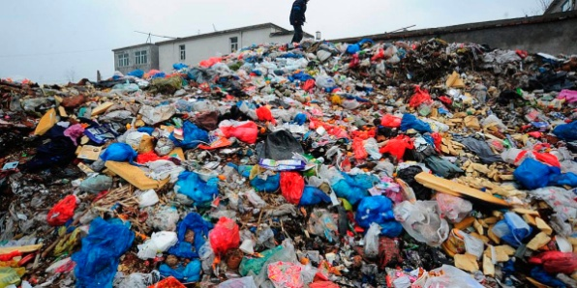 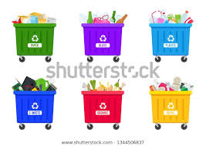

Energy

When we leave the room we should turn off the lights. We should use solar panels to improve our environment.

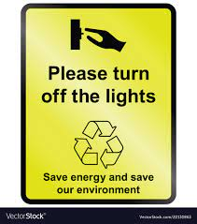 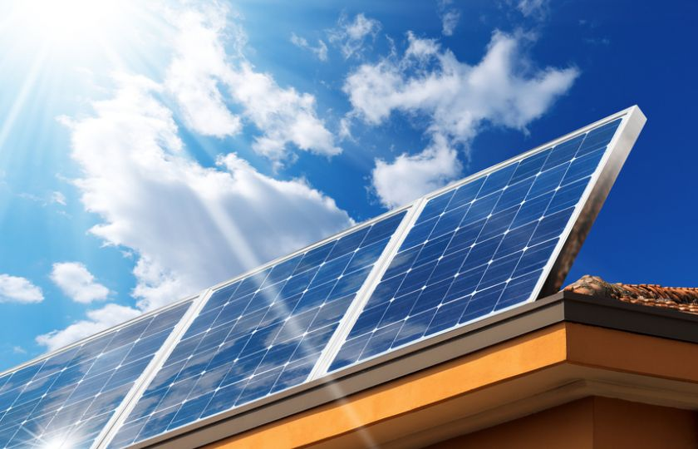

Trash in water

The garbage we are throwing in the water kills fish so we should stop doing that. Some fish eat the plastic and then when they are served in the restaurant we eat it too.

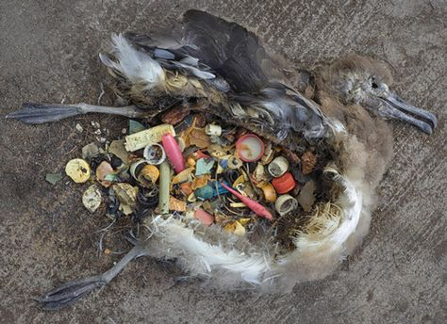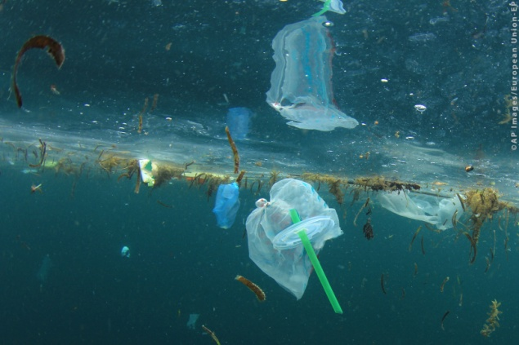

Written by D. Matějka, VIII.A